Paper No: Abstract title (Title case only. Leave the Paper No unchanged. This will be added after submission. Leave a blank line below the title)

A Author¹, B Author² and C Author^{1,2} (Initial and Surname for all authors, presenting author underlined)
¹Affiliation 1, Country, ²Affiliation 2, Country

1. Introduction
All accepted abstracts of presenting author registers by the presenters registration deadline (15 June 2019) will feature in the conference book of abstracts. Authors will also have the opportunity to submit a full paper (minimum 4 pages) of their work for the Journal of the SID. Please make your abstract look exactly like this document. The easiest way to do this is simply to open this template from within MS Word and replace the content with your own material. When you save the document, this template will automatically save as a .docx document. Please use a unique filename starting with the surname of the first author.

2. Page Size (Page Setup)
The page size has been set to A4. The top & bottom margins have been set at 2.54cm and the L & R at margins at 1.91 cm. The page is set in a two-column format after the title and author sections with a 0.8 cm gutter (gap between the columns). Please do not change any of these settings.

3. Text of Your Submission

3.1 Normal or Body Text
Please use the 10-point Arial font. Paragraphs must be justified (aligned left and right) as you see here, except for References, which should be left aligned.

3.2 Title and Authors
The title, authors' names and affiliations occupy the full width of the page.

3.4 References and Citations
Use the format shown in section 7 for references – a numbered list at the end of the paper with the authors in each reference placed in the order in which they appear in the referenced publication, and referenced by numbers in brackets [1].
References should be published materials accessible in the public domain. Internal technical reports may be cited only if they are easily accessible and may be obtained by any reader (you should give the address or URL to obtain the report within your citation). Proprietary information may not be cited.

4. Sections
The headings of sections are numbered sequentially in title case, left justified with no indent.

4.1 Subsections
The headings of subsections are numbered sequentially in title case. Note: For subsection headings, words like the, or, a are not capitalized unless they are the first word of the heading.

5. Tables/Figures/Captions
Place tables and figures in the text as closely to their reference as possible. Tables and figures may extend across both columns to a maximum width defined by the L & R margin tabs. Please place any figures and tables which extend across both columns at the top or bottom of the page.
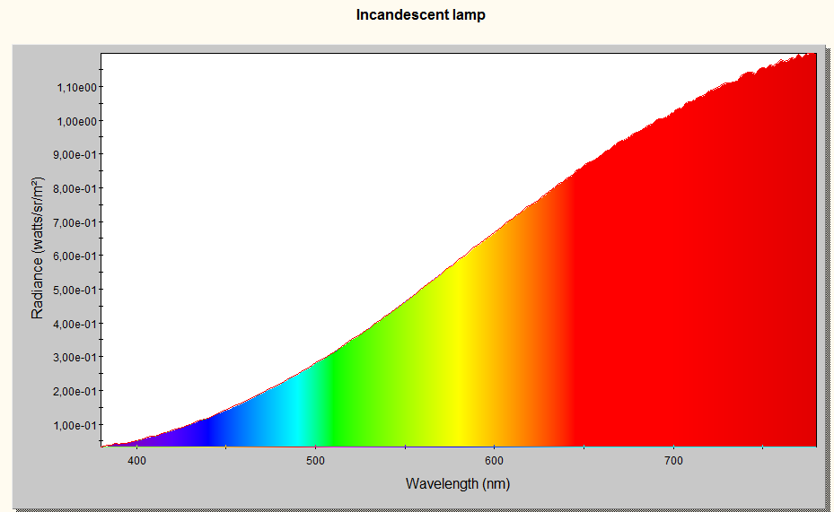
Figure 1: Visble spectrum of a very special lamp

Use the “insert text box” command to place a caption below a figure or above a table and then use the “group” command to group the figure or table with the caption. Captions are in Arial 9-point bold. They should be numbered (e.g., “Table 1” or “Figure 2”). Note that the words Table and Figure should not be abbreviated and that the caption must be centered.

6. Acknowledgements
Use this section to acknowledge help from supporting grants, permission to publish, etc.

7. References
- T. Afentakis, M. Stewart, R. Howell, M. Hatalis, "Polysilicon TFT Display Driver Circuits on Stainless Steel Foil Substrates" SID Symposium Digest, Vol. 33. pp. 538-541, 2000.
- S. Utsunomiya, S. Inoue, T. Shimoda, "Low-Temperature Poly-Si TFT Transferred onto Plastic Substrates by Using Surface Free Technology by Laser Ablation / Annealing", J. Info. Display, Vol. 10, pp. 69-73, 2002. (If a specific reference to a book is made, please enter the relevant page no. before the year.)

