REGISTRATION FORM
Name
Surname
Organization
E-mail
Paticipant category | - SID member  - Non SID member  - SID students  - Non SID students  - Accompanying Person
Category | - Invited Speaker  - Speaker  - Listener
Conference topics | Invited Speaker | Invited Speaker |  | Invited Speaker
Liquid crystal materials
OLED materials
Display materials
Thin film transistors
Liquid crystal displays
OLED displays
Micro-LEDs
Electronic ink
Virtual reality
Related applications
Metrology and standards
Production technologies
Choose your accomodation options | - Self-booking |  | - Delegate's Package

Delegate's package
For those who prefer early bird registration we would recommend to buy the delegate's package instead.

The delegate's package should be paid before or on 15 July 2019 and includes:
- early bird conference fee
- accommodation in the Minsk Marriott Hotel at a reduced price within the dates
15-21 September 2019 (according to the data provided in your online registration)
- airport-hotel-airport transfer for 10 € (regular taxi price is 25-30 €) and meeting
by the organizer's team at the airport

Delegate’s package fee will be calculated individually based on the participant category, duration of stay and chosen room category in the Minsk Marriott Hotel.

Departure / Arrival day
Arrival day | 15 Sep | 16 Sep | 17 Sep | 18 Sep | 19 Sep | 20 Sep | 21 Sep
Departure day | 15 Sep | 16 Sep | 17 Sep | 18 Sep | 19 Sep | 20 Sep | 21 Sep
Accommodation option
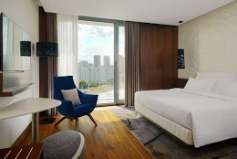
- Classic / Standard room with the view of the city (1-person accommodation,  King Size Bed) |  |  | - Classic / Standard room with the view of the river  (1-person accommodation, King Size Bed)
 |  |  | 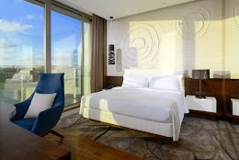
- Classic / Standard room with the view of the river (2-person accommodation, Queen Size beds) |  |  | - Hospitality Suite
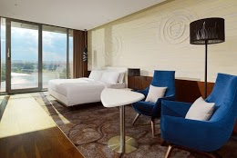 |  |  | 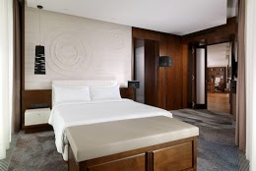
- Premium Suite |  |  | - Luxury Suite
Contact us
Tel: +375 17 293 88 58
Fax: +375 17 292 98 26
E-mail: eurodisplay2019@gmail.com
https://eurodisplay2019.bsuir.by

